**Baitboat Andriod App Specification:**

Designing an android app to control a bait boat (shown below) remotely. The bait boat is used to capture fish based on the information provided by the sonar sensor embedded in the boat (Deeper Fishfinder Pro – comes with an app called Deeper (available on Google Play)).

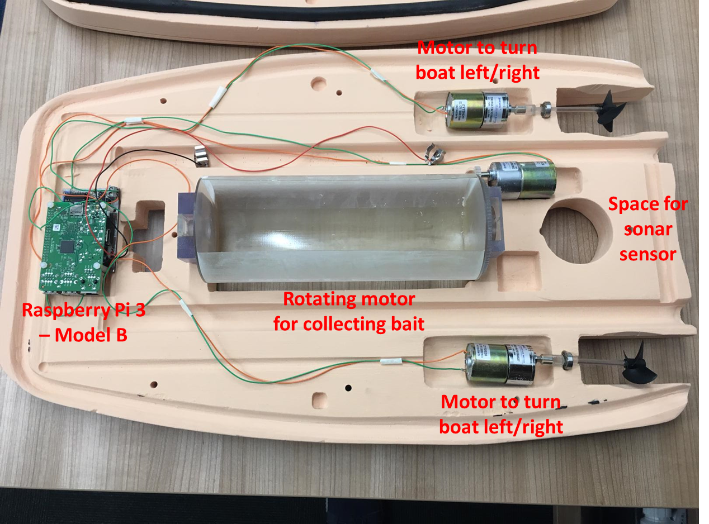

Suggested interface for the baitboat app:

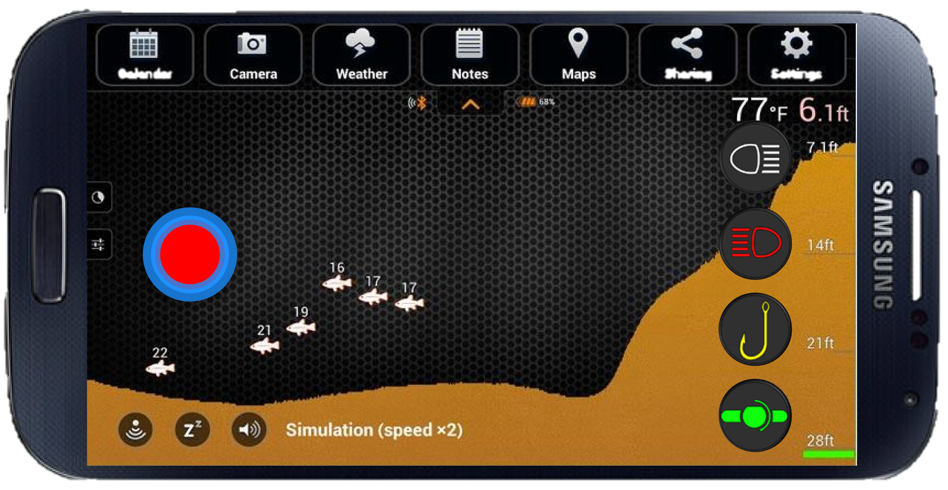

1. Left hand side circle in circle analog joystick to steer the boat (left/right)
   1. Steer left
   2. Steer right
   3. Straight ahead
   4. Reverse
2. The app should transmit commands to a remote interface over WiFi ideally ssh i.e. on change of control status, issue ssh command with updated parameters.